13.3.4 Editors - Video Sequence Editor - Sidebar - Sequencer - Tool tab
Tool Tab 1
Tool Tab and Top Bar 1

Tool Tab
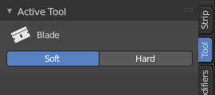
In the tool tab you will find the tool related settings for the tools in the tool shelf. These settings are explained for the single tools in the tool shelf chapter.

Tool Tab and Top Bar

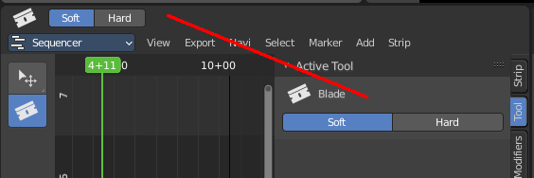
The content in the Tool Tab is besides one panel the same than in the Topbar.
Different from the 3D view, he top bar cannot be hidden.

